MAGNETIC ANOMALIES, LONG WAVELENGTH

Long wavelength anomalies are static or slowly varying features of the geomagnetic field, and originate largely within the lithosphere. These anomalies stand in contrast to the rapidly time varying features characteristic of even longer wavelengths, which originate within the outer core. An inflection point, or change of slope, in the geomagnetic power spectrum (Figure 1) can be seen at degree 13 and is a manifestation of the relatively sharp transition from core-dominated processes to lithospheric-dominated processes. Long-wavelength anomalies (Figure 2A) are most easily recognized from near-Earth satellites at altitudes of 350 to 750 km, and these altitudes define the shortest wavelengths traditionally associated with such geomagnetic features. The lithospheric origin of these features was firmly established by comparison with the marine magnetic record of seafloor spreading in the North Atlantic (LaBrecque and Raymond, 1985). Virtually identical features have now been recognized in satellite magnetic field records from POGO (1967-1971), Magsat (1979-1980), Ørsted (1999-), and CHAMP (2000-). Long wavelength anomalies were first recognized by Cain and coworkers in about 1970 on the basis of total field residuals of POGO data.

Although electrical conductivity contrasts (Grammatica and Tarits, 2002) and motional induction of oceanic currents (Vivier et al, 2004) can produce quasi-static long-wavelength anomalies, the largest contributors to long wavelength anomalies are induced (M_{i}) and remanent (M_{r}) magnetization in the earth’s crust. Contributions from the uppermost mantle may also be of importance, at depths where temperatures do not exceed the Curie temperature (T_{c}) of the relevant magnetic mineral. The earth’s main field (H) is the inducing magnetic field responsible for induced magnetization of lithospheric materials. M_{i} = kH expresses the linear relationship between the inducing field and induced magnetization, true for small changes in the inducing field. k is the volume magnetic susceptibility, treated here as a dimensionless scalar quantity, and reflects the ease with which a material is magnetized. If M does not return to zero in the absence of H, the resulting magnetic field is said to be remanent or permanent. Thus M = M_{r} + M_{i}, and the relative strength of the two contributions is referrred to as the Koenigsberger ratio or Q=M_{r}/M_{i}.

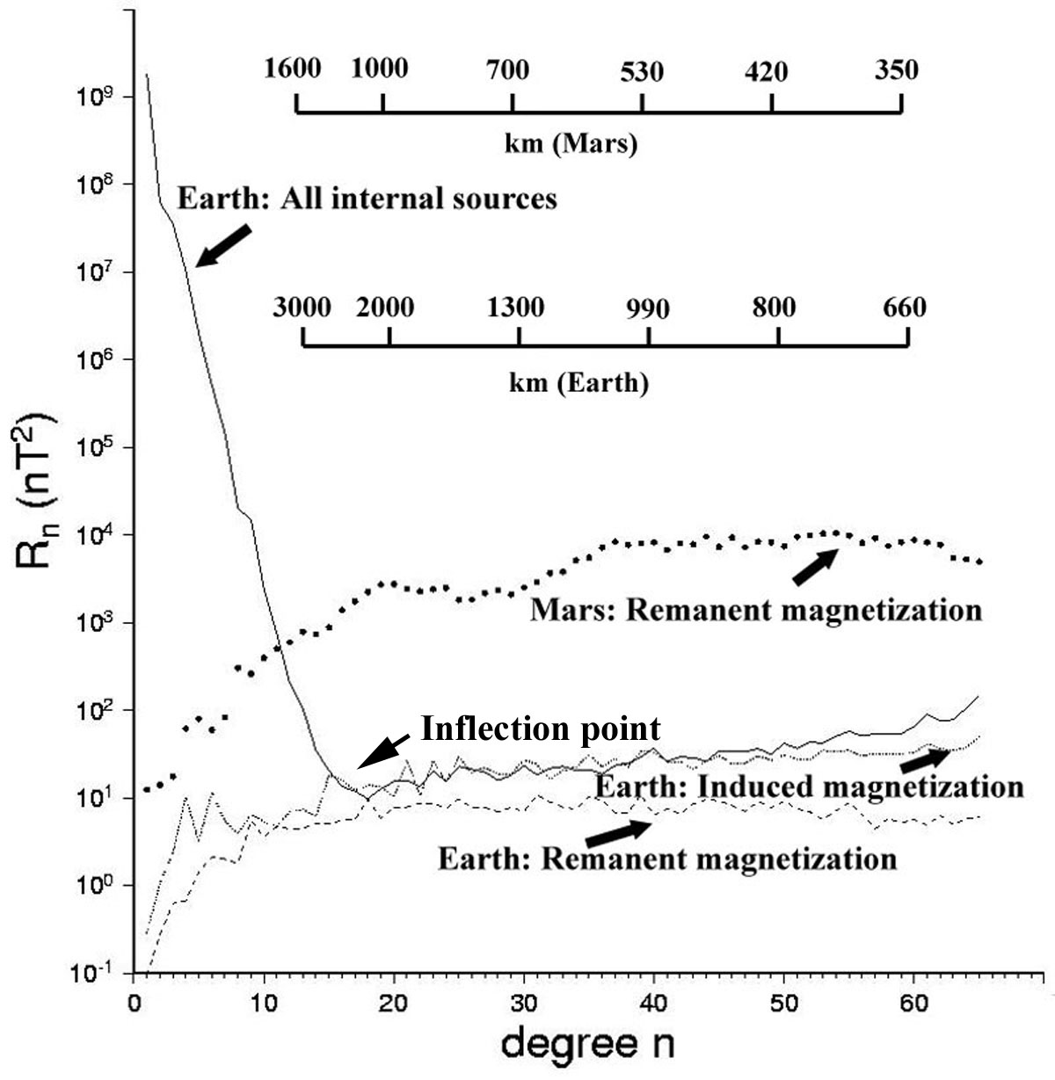
Figure 1. Comparison of the Lowes-Mauersberger (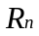) spectra at the surface of the Earth and Mars for a variety of internal fields. The inflection point in the terrestrial power spectra represents the sharp transition from core processes at low n to lithospheric processes at higher n. is the mean square amplitude of the magnetic field over a sphere produced by harmonics of degree n. The terrestrial spectrum of all internal sources comes from Sabaka et al. (2004), the Martian remanent spectrum is derived from Langlais et al. (2004), the terrestrial induced spectrum is derived from Fox Maule et al. (2005), and the terrestrial remanent magnetization spectrum (of the oceans, and hence a minimum value) was derived from Dyment and Arkani-Hamed (1998).

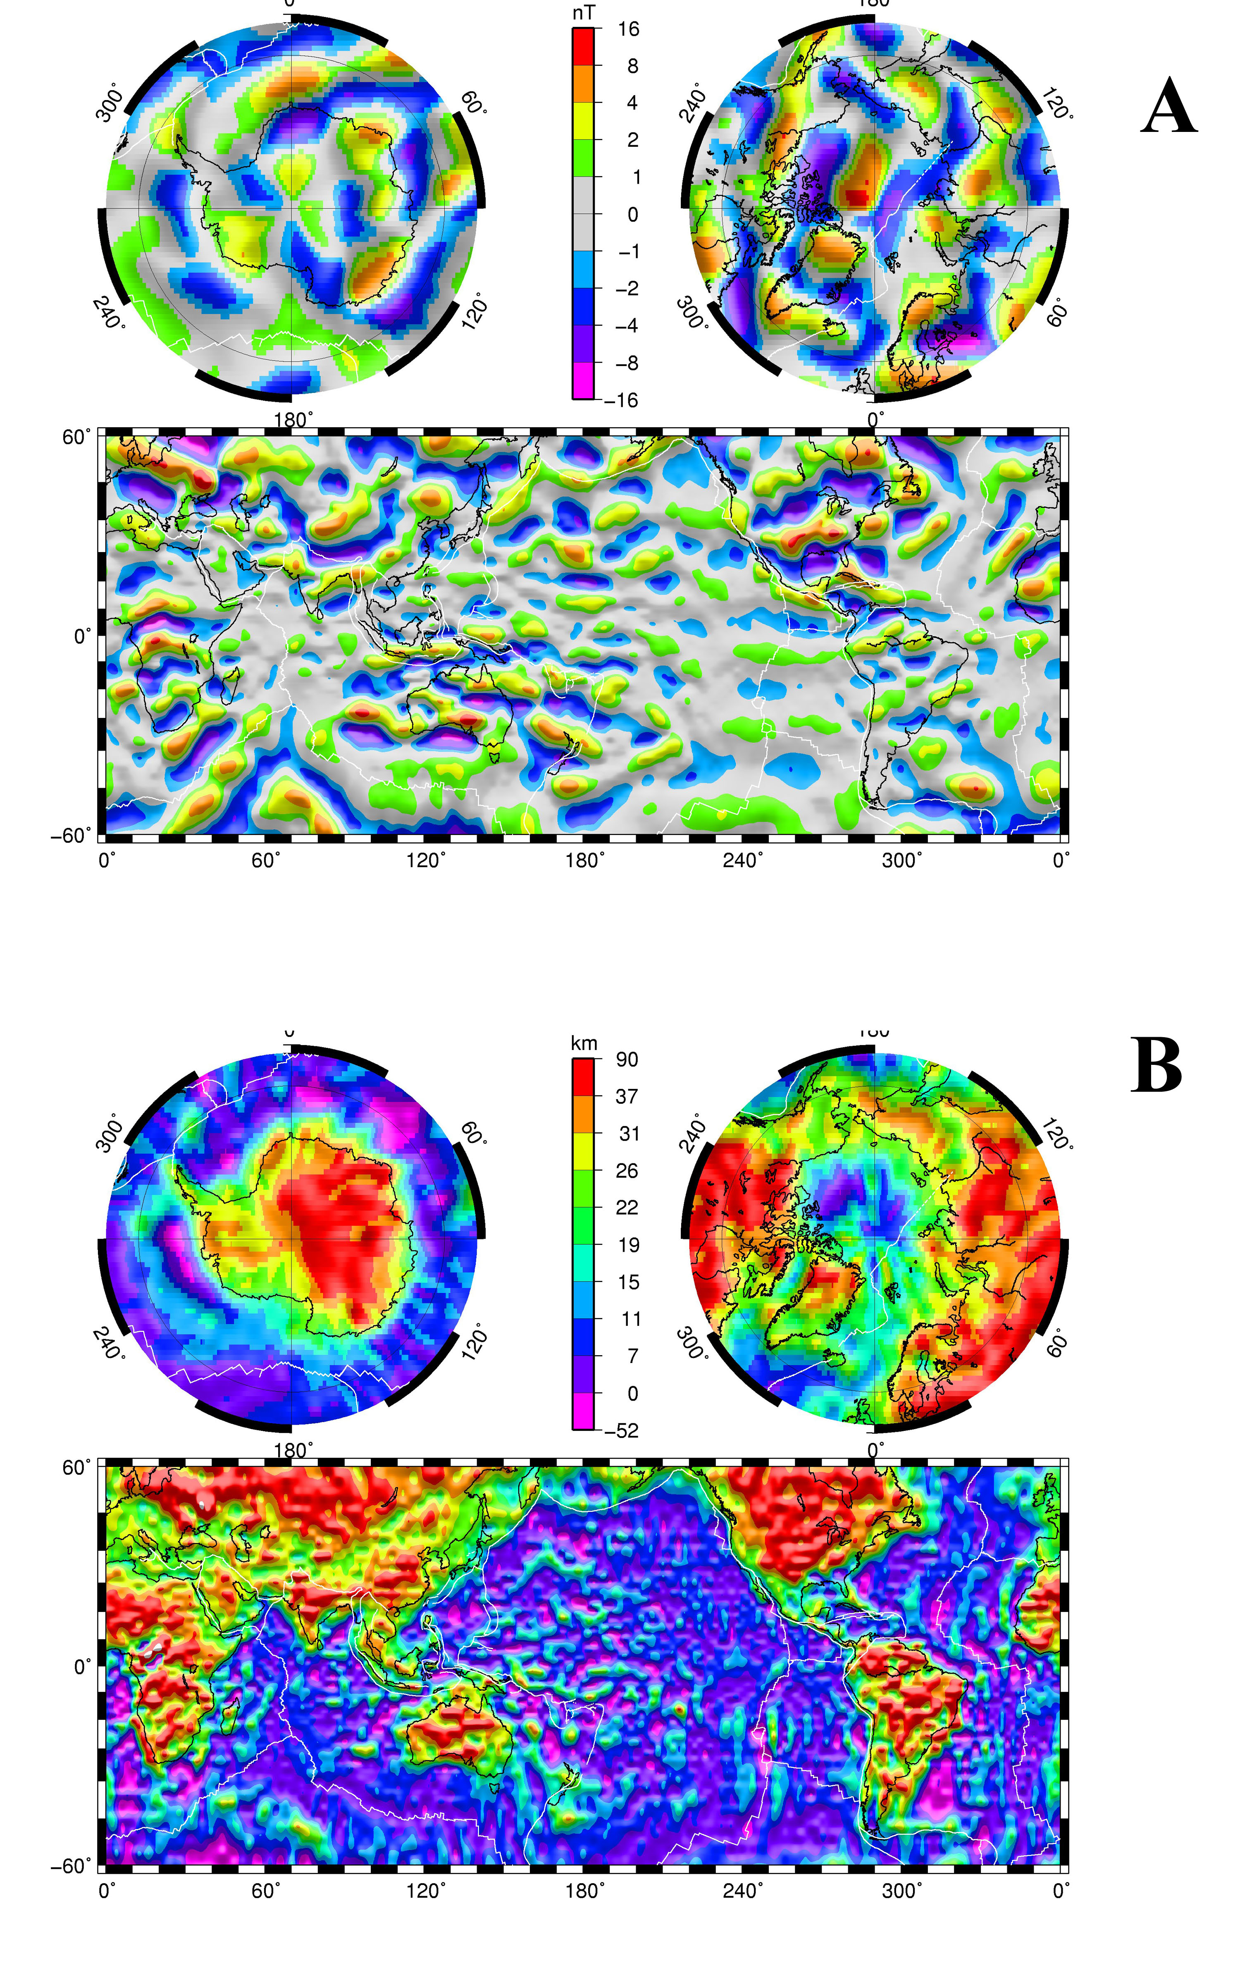

Figure 2. Long-wavelength anomalies (A) in the total field as seen by the CHAMP magnetic field satellite at an altitude of 400 km (MF-4 model of GFZ-Potsdam available at www.gfz-potsdam.de/pb2/pb23/SatMag/model.html). Spherical harmonic degrees between 16 and 90 are included within this map. The magnetic crustal thickness (B), derived as described in Fox Maule et al., 2005, explains the observations in (A). The map uses as a starting model the 3SMAC (Nataf and Ricard, 1996) compositional and thermal model of the crust and mantle. 3SMAC is modified in an iterative fashion with the satellite data, after first removing a model of the oceanic remanent magnetization (Dyment and Arkani-Hamed, 1998), until the magnetic field predicted by the model matches the observed magnetic field. A unique solution is obtained by assuming that induced magnetizations dominate in continental crust, and that vertical thickness variations dominate over lateral susceptibility variations (Purucker et al., 2002). A starting model such as provided by 3SMAC is necessary to constrain wavelengths longer than about 2600 km. Longer wavelengths are obscured by overlap with the core field. The white lines delineate plate boundaries, transform faults, and mid-ocean ridges. Illumination on these shaded relief maps is from the east.
Inversions of long-wavelength anomaly observations into lithospheric source functions, for example magnetic crustal thickness (Figure 2B) are subject to many caveats. Simple solutions are preferred, which also agree with other independently determined lithospheric properties. Specific caveats with respect to inversions of these magnetic field observations are that 1) direct inversion, in the absence of priors, can uniquely determine only an integrated magnetization contrast, 2) a remarkably diverse assemblage of magnetic annihilators (Maus and Haak, 2003) exist which produce vanishingly small magnetic fields above the surface, and 3) the longest wavelength lithospheric magnetic signals are obscured by overlap with the core and it is formally impossible to separate them.

Unresolved research questions include 1) the continuing difficulty of signal separation, especially with respect to external fields (Sabaka et al.,2004), and the particular problem of resolving north-south features from polar-orbiting satellites, 2) the relative importance of magnetic crustal thickness variations and magnetic susceptibility variations in producing long-wavelength anomalies 3) the relative proportions of induced and remanent magnetization in the continents and oceans 4) the mismatch between the observed long-wavelength fields at satellite altitude, and surface fields upward continued to satellite altitude 5) the separation of long wavelength anomalies caused by motional induction of large-scale ocean currents 6) the isolation and relative importance of shorter wavelength anomalies (between 660 and 100 km wavelength), and finally 7) the origin of the order of magnitude difference between the observed lithospheric magnetic fields of the Earth and Mars.

Bibliography
Dyment, J. and Arkani-Hamed, J., 1998, Contribution of lithospheric remanent magnetization to satellite magnetic anomalies over the world’s oceans, J. Geophys. Res., 103, 15423-15441.

Fox Maule, C, Purucker, M., Olsen, N., and Mosegaard, K., 2005, Heat flux anomalies in Antarctica revealed by satellite magnetic data, Science, 10.1126/science.1106888.

Grammatica, N. and Tarits, P., 2002, Contribution at satellite altitude of electromagnetically induced anomalies arising from a three-dimensional heterogeneously conducting Earth, using SQ as an inducing source field, Geophys. J. Int., 151, 913-923.

LaBrecque, J.L. and Raymond, C.A., 1985, Seafloor Spreading Anomalies in the MAGSAT field of the North Atlantic, J. Geophys. Res., 90, 2565-2575, 1985.

Langel, R.A., and Hinze, W.J., 1998, The Magnetic Field of the Earth’s Lithosphere. Cambridge; Cambridge University Press.

Langlais, B., Purucker, M, and Mandea, M., 2004, Crustal magnetic field of Mars, J. Geophys. Res., 109, E02008, doi:10.1029/2003JE002048.

Maus, S. and Haak, V., 2003, Magnetic field annihilators: invisible magnetisation at the magnetic equator, Geophys. J. Int, 155, 509-513.

Nataf, H. and Ricard, Y., 1996,3SMAC: an a priori tomographic model of the upper mantle based on geophysical modeling, Phys. Earth Plan. Int., 95, 101-122.

Purucker, M., Langlais, B., Olsen, N., Hulot, G., and Mandea, M., 2002, The southern edge of cratonic North America: Evidence from new satellite magnetometer observations, Geophys. Res. Lett., 29(15), 8000, doi:10.1029/2001GL013645.

Sabaka, T.J., Olsen, N and Purucker, M, 2004, Extending Comprehensive Models of the Earth’s Magnetic field with Ørsted and CHAMP data, Geophys. J. Int., 159, 521-547.

Vivier, F., Maier-Reimer,E., and Tyler, R.H., 2004, Simulations of magnetic fields generated by the Antarctic Circumpolar Current at satellite altitude: Can geomagnetic measurements be used to monitor the flow?, Geophys. Res. Lett., 31, L10306, doi:10.1029/2004GL019804.

Cross References
Magsat, POGO, CHAMP, Ørsted, Spherical Harmonics, Magnetic Field of Mars, Marine magnetic anomalies, Marine Magnetic Surveys

Michael E. Purucker

